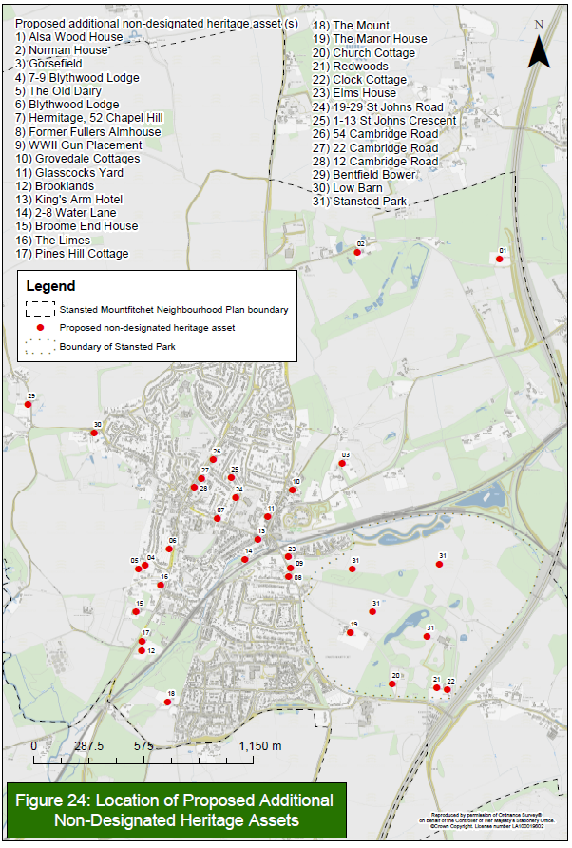
APPENDIX 24 - Proposed Heritage Assets

